Week 7 Lab

Nguyen Nam Tung 103181157

7.1.1.

This value is displayed because we are changing the value to hexadecimal (from decimal)

7.1.2.

This value is displayed because we are changing the value to hexadecimal

7.1.3.

This value is displayed because we are changing the value to hexadecimal (from binary)

7.1.4.

No, it will not change. But the data inside the memory box will change.

7.2.1.

Because 4 bytes are used to represent each word.

7.3.1.

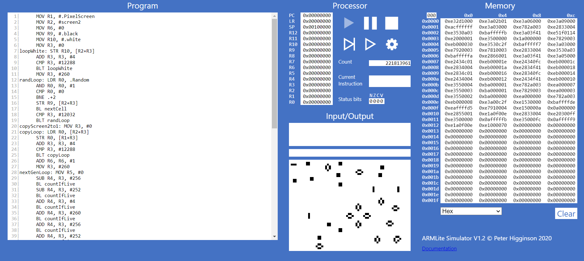

7.3.2.

The thing that shows up is the place that store the memory/value

7.3.3:

- The blank lines and additional spaces will not be stored in the memory

- The comments will be coloured after the code is submitted.

- The line number, if the comment is added, will increase. Otherwise, will stay the same.

- If we replace the comma in the first line of code, an error will be displayed.

7.4.1.

Red: Next step

Black: Slow

7.4.2.

Increase the line being executed.

7.4.3.

The code before the break line will be executed.

7.5.1.

The MOV command is moving 1 into R0, then, ADD command is used to plus 8 with R0(1) and pass the value 9 (8+1) to R1

When the SUB command is executed, R2(109) minus 25 and pass the value to R3

The value 84, which we are looking for is R3

7.5.2.

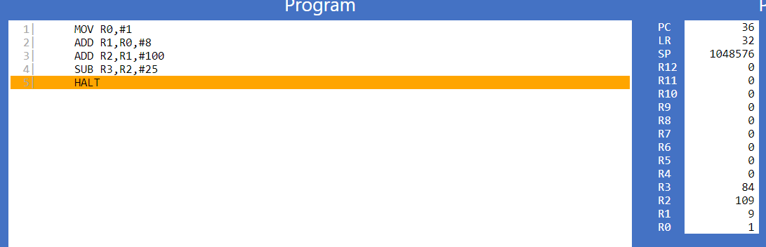

7.5.3.

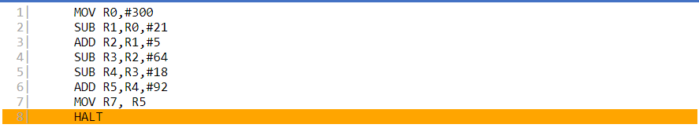

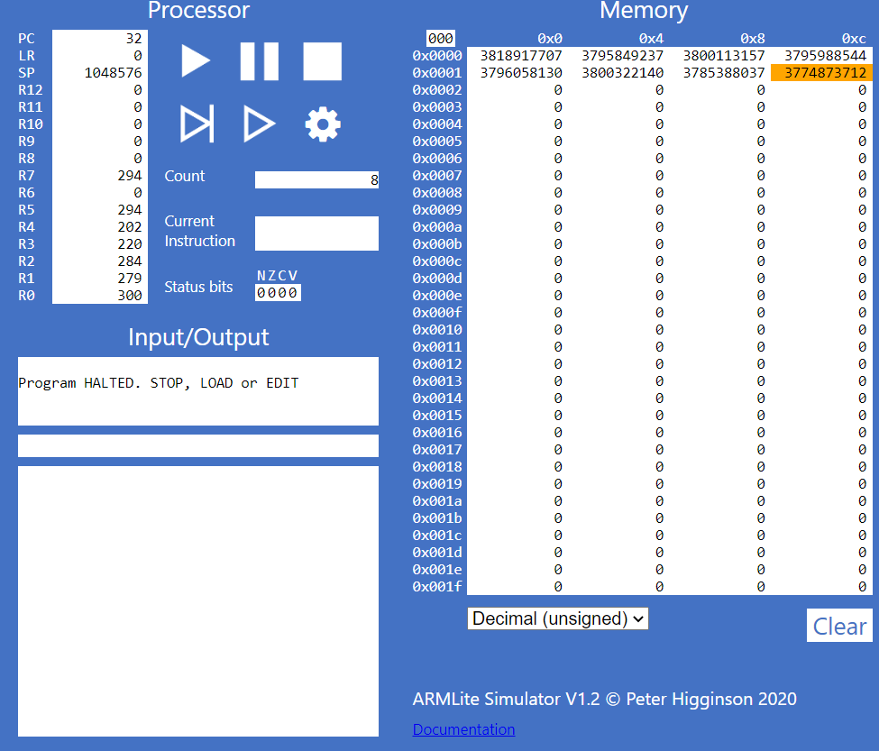

7.5.4.

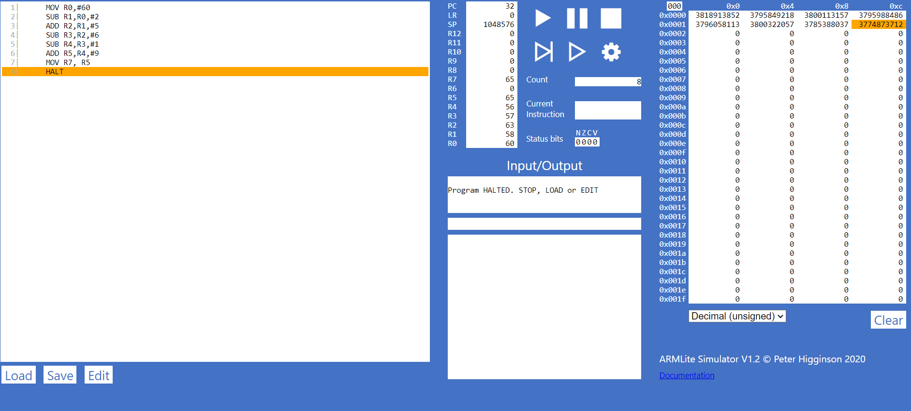

7.5.5.

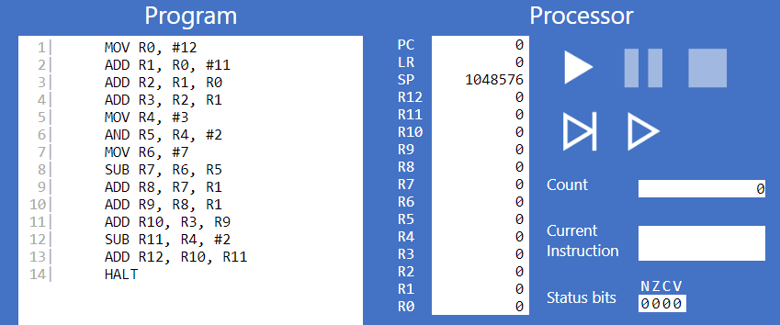

7.6.3.

The pattern is that negative number (in binary ) is flipped , then add 1.

7.6.4.

